**WORKFLOW DOCUMENTATION**

1. Go to the source of the focal dataset and download the csv file from: <http://catalog.data.gov/dataset/choose-maryland-compare-states-demographics>

The file will be downloaded as Choose_Maryland___Compare_States_-_Demographics.csv

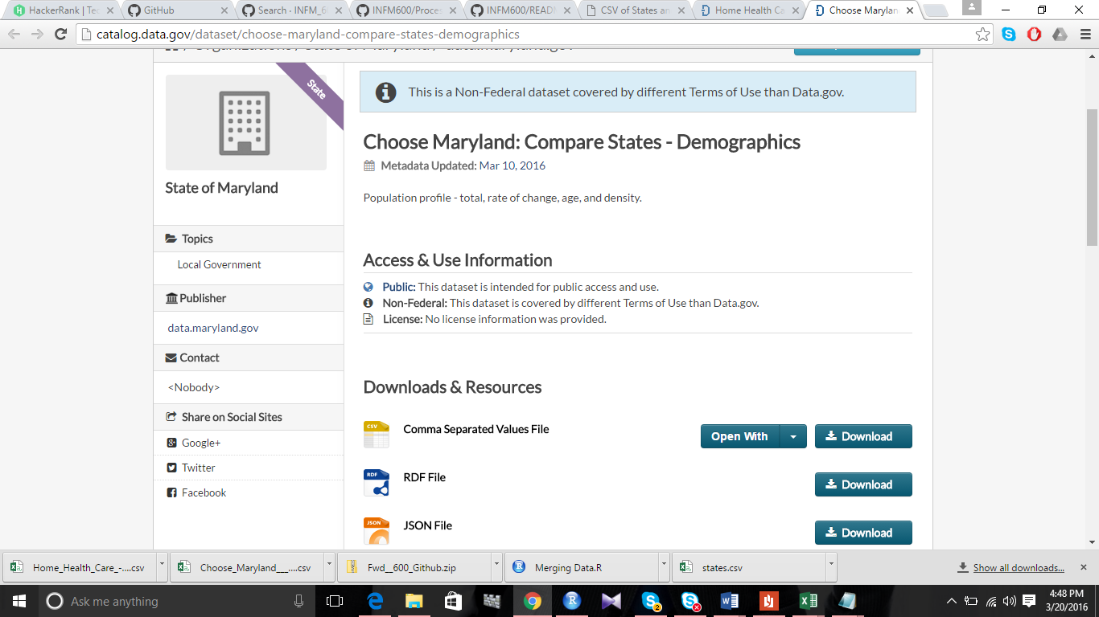

1. Similarly download the csv versions of the supporting datasets from: <http://catalog.data.gov/dataset/home-health-care-state-by-state-data>, <http://catalog.data.gov/dataset/choose-maryland-compare-states-quality-of-life-2798c> and <http://www.fonz.net/blog/archives/2008/04/06/csv-of-states-and-state-abbreviations/>

These files will be downloaded as Home_Health_Care_-_State_by_State_Data.csv, Choose_Maryland___Compare_States_-_Quality_Of_Life.csv and states.csv respectively.

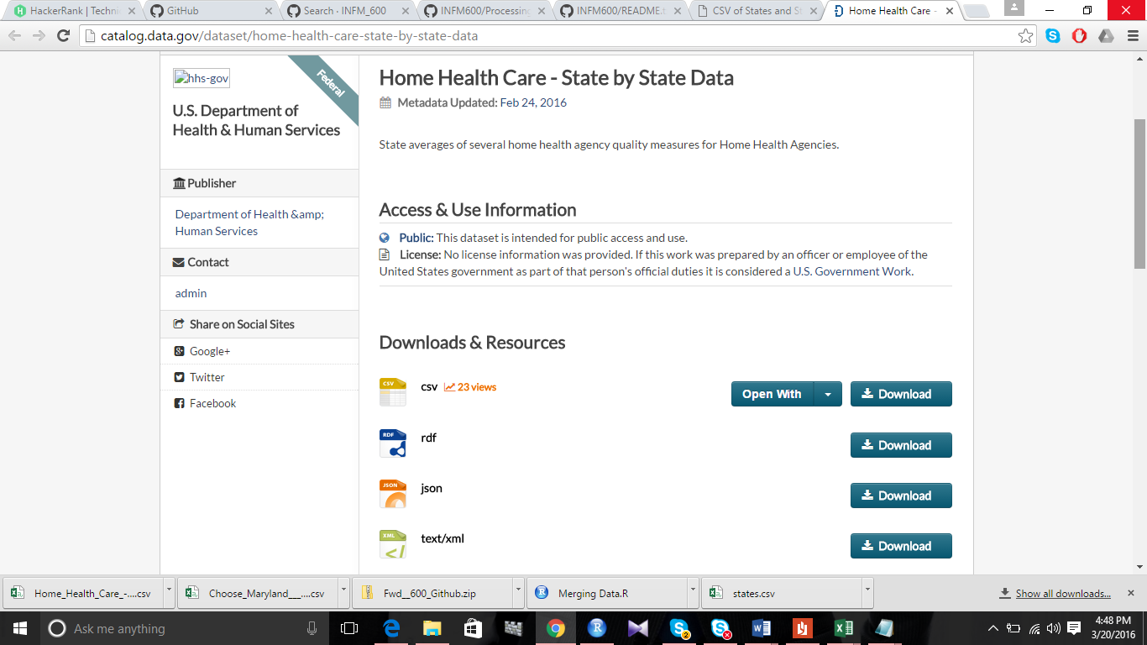

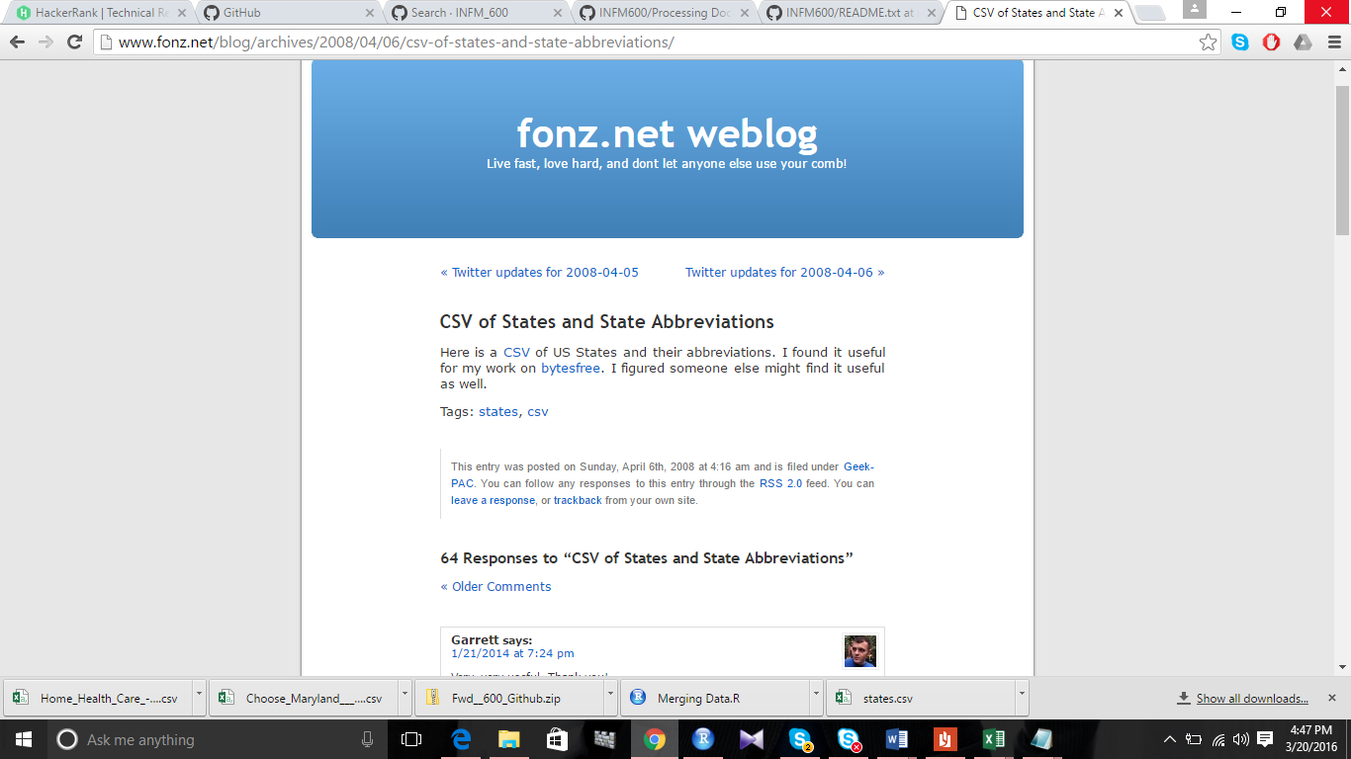

1. Merging the three datasets (using R)
2. Move the downloaded files to a directory and set the directory in R as the same directory.
3. Read the files in R. Merge states.csv and focal dataset using the common column ‘State’ and save the file as demo_complete.
4. Now, combine the Home_Health_Care_-_State_by_State_Data.csv and demo_complete using the abbreviation for states. Then combine the Choose_Maryland___Compare_States_-_Quality_Of_Life.csv file and get the final dataset to be processed.
5. Write this final file as IncomeAndQuality.csv and save it in the same folder.
6. The resulting file, IncomeAndQuality.csv should be cited as Nevagi, S (2016). IncomeAndQuality [Data CSV file]. Available from <https://github.com/snevagi/INFM_600/>. The data in the INFM600 repository is distributed under a creative commons attribution - NonCommercial - ShareAlike 4.0 International License (see <http://creativecommons.org/licenses/by-nc-sa/4.0/>).

**References:**

1. Data.gov State of Maryland (2016) Choose Maryland: Compare States - Demographics [Data set CSV file]. Retrieved from [http://catalog.data.gov/dataset/choose-maryland-compare-states-demographics. March 19,2016](http://catalog.data.gov/dataset/choose-maryland-compare-states-demographics.%20March%2019,2016)
2. Data.gov U.S. Department of Health & Human Services (2016) Home Health Care - State by State Data [Data set CSV file]. Retrieved from http://catalog.data.gov/dataset/home-health-care-state-by-state-data. March 19,2016
3. Data.gov State of Maryland (2016) Choose Maryland: Compare States - Quality Of Life [Data set CSV file]. Retrieved from http://catalog.data.gov/dataset/choose-maryland-compare-states-quality-of-life-2798c. March 19,2016
4. Nevagi, S., Piscetelli, M. (2016). IncomeAndQuality [Data CSV file]. Available from https://github.com/snevagi/INFM600/.